Maintenance Job Description |  | 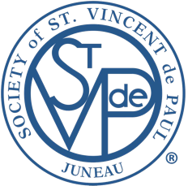
Title
Maintenance Staff
Department  Maintenance | Manager  Maintenance Manager
Prepared by  Dave Ringle, Executive Director | Date prepared  May 7, 2021
Description
Summary
- Under general supervision of Maintenance Manager, performs a variety of work in the general maintenance and repair of apartments, office facilities, St. Vincent Store, grounds and equipment.
Primary Responsibilities
- General Maintenance:
  - respond to service requests
  - reports and respond to emergency-calls for custodial assistance
  - maintenance and repairs to rental housing units
  - maintenance and repairs to structural, mechanical and electrical systems
  - maintenance and repairs of building interiors and exteriors including finishing, ceilings, flooring and roofing
  - handle routine maintenance repair, including:
    - garbage disposal stoppage/minor appliance repairs
    - faucet leaks/ washer replacement
    - painting (interior and exterior)
    - replace light bulbs in common areas, rooms and apartments
    - assist the maintenance team in getting units ready for rent
- Grounds Maintenance, including:
  - clean stairs, decks, sidewalks weeding
  - trims tree branches that create hazardous situations
  - replaces outside bulbs in lighting fixtures which requires climbing a ladder clean garbage and debris on grounds
  - snow removal/ clearance of sidewalk as needed moving furniture and other stuff
Other Requirements
- Minimum GED diploma or equivalent or experience commensurate with requirements of the position and proven ability to read labels, instructions, etc.
- A valid Alaska Driver's License and ability to covered by St. Vincent de Paul Society insurance
- Can provide own hand and portable power tools (purchase assistance may be available)
- Legal residency and possession of documentation permitting employment
- Ability to pass a criminal and sex offender background check
- Ability to meet the criteria for employee honesty bonding

